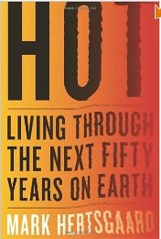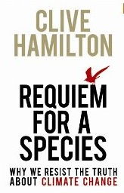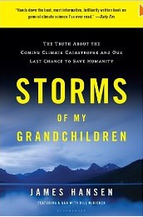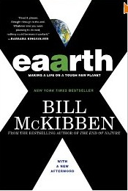

Learning From The “Eco-Doom” Books
Edward Church, Ph.D., Shripal Shah, MBA
Institute for Environmental Entrepreneurship

A review of four leading books on climate change and its effects:

Bill McKibben, Eaarth: Making a Life on a Tough New Planet.
Clive Hamilton, Requiem for a Species: Why We Resist the Truth about Climate Change.
Mark Hertsgaard, Hot: Living through the next Fifty Years on Earth.
James E. Hansen, Storms of My Grandchildren: The Truth about the Coming Climate. Catastrophe and Our Last Chance to save Humanity.

Most book reviews are published to alert the reader to a book they might be interested in reading, and offer the reader judge enough information to judge for themselves. Publications on sustainability or green business regularly review new books, but they do not follow a standard practice in many disciplines of comparing and contrasting books on the same topic. We wanted to explore what those engaged in “sustainability” can learn from that practice, and to do so, we have chosen important works for a general audience about what many consider to be the focal point of planetary sustainability: understanding, and reducing or coping with, climate change brought on by global warming.

The concept of “sustainability” is seen by many as the antidote to our most pressing global problems. Yet, currently it has neither the analytical nor the prescriptive power adequate to the task. It is a loose grouping of unrelated publications, videos, speeches, or blog posts, which are not pulled together for productive use. How do we begin acting as if sustainability were a science? What might that look like? We at the Institute offer this excerpt from our multi-book review to demonstrate the power of organizing and structuring existing sources of knowledge. More information about the Institute, as well as the full review, can be found at www.enviroinstitute.org.

Each of these books demands attention individually, and contributes significantly to the issue. We think that there is added value in viewing them as a group. They were all written at about the same time, close to 2009, but by authors with very different backgrounds and home bases.
While each book has a provocative title and their themes are challengingly dismal, writing a book is an inherently optimistic exercise, especially so when the author recommends remedies to problems identified. We extend their optimism by suggesting that their individual calls for action can be amplified by taking them as parts of a compelling whole.

We found a kind of unity in the four authors’ divergent views. Each author describes climate change scenarios that range from dramatic to calamitous, but even the least dramatic necessitates definitive, timely and strong action. The climate science they begin with is both literally and figuratively sky-high. It is mathematically and atmospherically ethereal, the product of decades of rigorous scientific work which is usually not accessible to the lay reader. The authors’ task is to make that work as real and understandable to the public and policy makers as it is to the scientists, which they do commendably. The climate change “science” they distill is basically the same across authors, so the scientific front ends of the books are quite similar. The back end prescriptions for action are quite different, reflective perhaps of the authors’ differing biographies and geographies.

Each author brings the implication of their analysis squarely down to earth. Bill McKibben centers his prescriptions on localized action, Mark Hertsgaard on adaptations and mitigations that are a bit larger in scale, Clive Hamilton on fundamental cultural and behavior shifts, and James Hansen on international-scale planetary projects and policies. At the level of solutions, their narrative and examples are textured with a tangible physicality, a physicality of place, land, water, and people. Across the books, the large-scale public analysis, and the private impacts and actions, become one.

The intellectual abstractions of climate change and the physical impacts are brought together by a moral and ethical imperative. It is significant that the connective tissue between the two is moral. Nothing in science itself compels solutions, and although the “science” of global warming provides information, by itself it provides no guidance for action.

Solutions can be derived from a number of premises for action. One dominant mode of action to mitigate global warming is the proliferation of “green tech” solutions, attached to the potential for personal profit. Geopolitical gain is another motive for seeking solutions, to mitigate the ramifications of climate change. Yet, the four authors choose to organize their analysis and solutions based on moral and ethical considerations of the impact of global warming on others, whether in other lands or coming generations. The authors’ distillation of causes and effects into actions based on a shared morality democratizes both the problems and the solutions.

Moral exhortations are self-limiting without specific application, but with it, they can be quite productive. Each author converts abstract scientific findings into very physical impacts and recommendations for action—and the impulse for the conversion is moral obligation to others. Hertsgaard, for example, frames his book in terms of his obligation to his daughter, and Hansen to his granddaughter.

Our reviews themselves also act as a primer on the topic of global warming, detailed at length in the books themselves. In the full review (available at www.enviroinstitute.org) we take central themes in the four books and compare them for similarities and differences. We cover causes and effects of climate change, predictions, and remedies. We also offer Appendices, author biographies and information about the sources of information they used.

* * * * *

